**Business Question and Visualization Report**

|  |  |
| --- | --- |
| Date | 03 October 2025 |
| Team ID | SWUID20250215169 |
| Project Name | Global Food Production Trends and Analysis:  A Comprehensive Study from 1961 to 2023 Using Power BI |
| Maximum Marks | 5 Marks |

Visualization development refers to the process of creating graphical representations of data to facilitate understanding, analysis, and decision-making. The goal is to transform complex datasets into visual formats that are easy to interpret, enabling users to gain insights and make informed decisions. Visualization development involves selecting appropriate visual elements, designing layouts, and using interactive features to enhance the user experience. This process is commonly associated with data visualization tools and platforms, and it plays a crucial role in business intelligence, analytics, and reporting

**Business Questions and Visualisation**

The process involves defining specific business questions to guide the creation of meaningful and actionable visualizations in Power BI. Well-framed questions help in identifying key metrics, selecting relevant data, and building visualisation that provide insights.

The project aims to analyze global food production trends to understand how agricultural output has evolved across regions, crops, and time. The following business questions were defined to guide meaningful Power BI visualizations that provide clear insights and data-driven conclusions.

**Sample**

1. **How has global food production changed over time (1961–2023)?**

* **Visualization:** Line chart showing total global production trends across years.

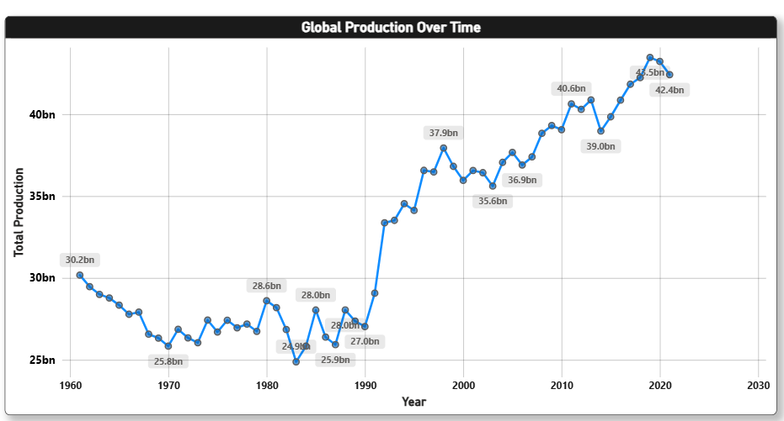

**2.** **Which regions contribute the most to global food production?**

* **Visualization:** stacked column chart comparing total production across major regions.

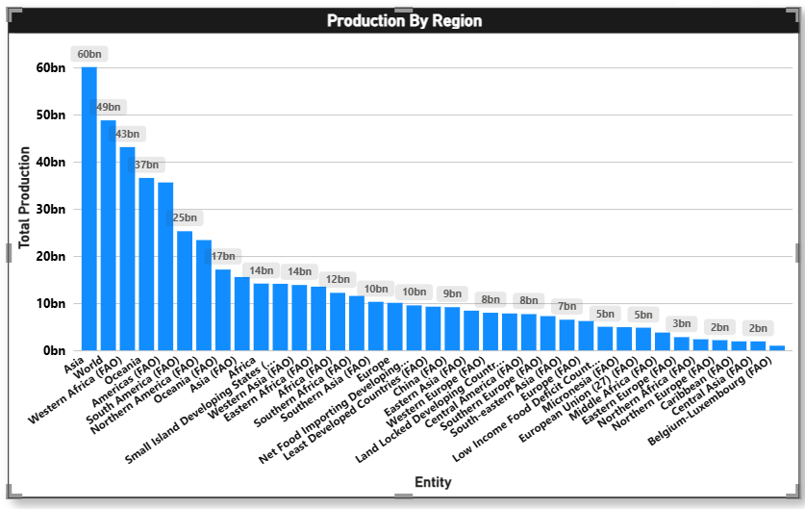

**3. What are the top food crops produced globally?**

* **Visualization:** Bar chart showing top 10 crops by production volume.

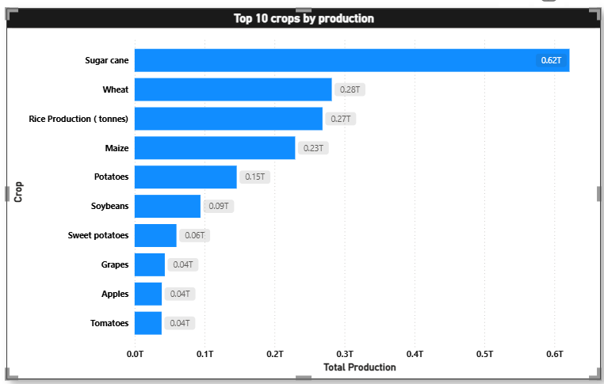

**4. How does production differ between countries within each region?**

* **Visualization:** Map visualization displaying production by country.

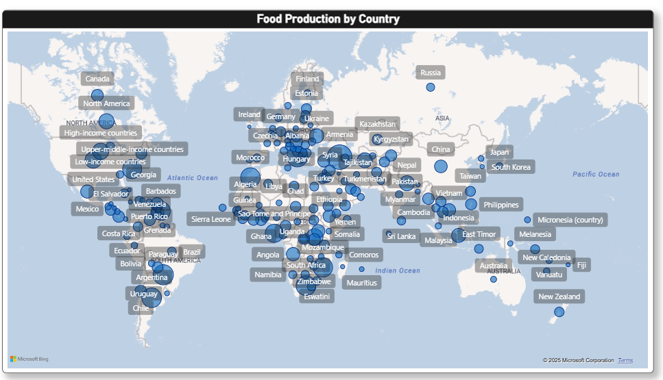

**5. How has the production of specific crops (like wheat, rice, or maize) evolved over the years?**

* 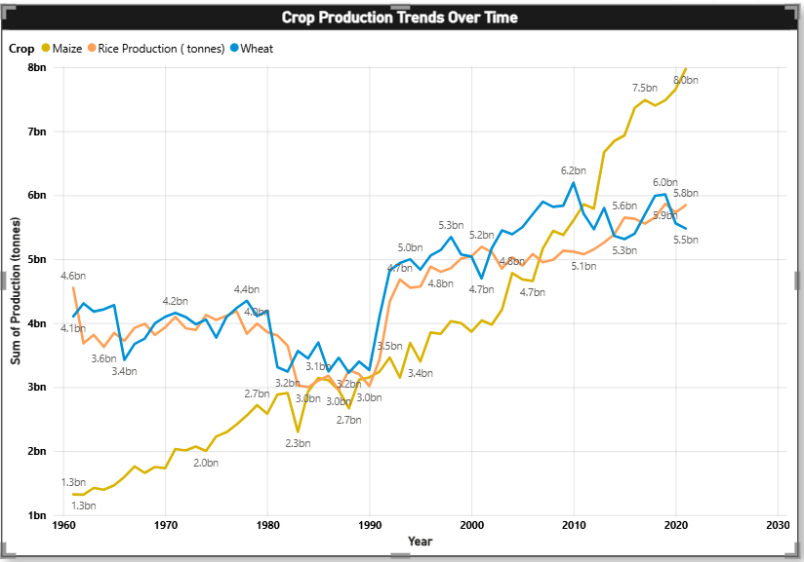 **Visualization:** Line chart showing crop-wise production trends over time.

**6. Which region dominates the production of key staple crops?**

* **Visualization:** Clustered bar chart comparing production of selected crops (e.g., rice, maize, wheat) across regions.

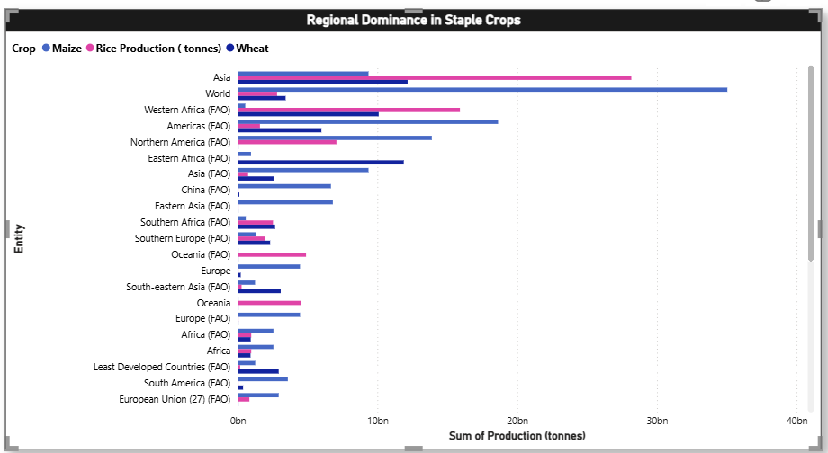

**7. What percentage of total global production is contributed by each crop type?**

* **Visualization:** Pie or donut chart showing contribution percentages of crops to global total production.

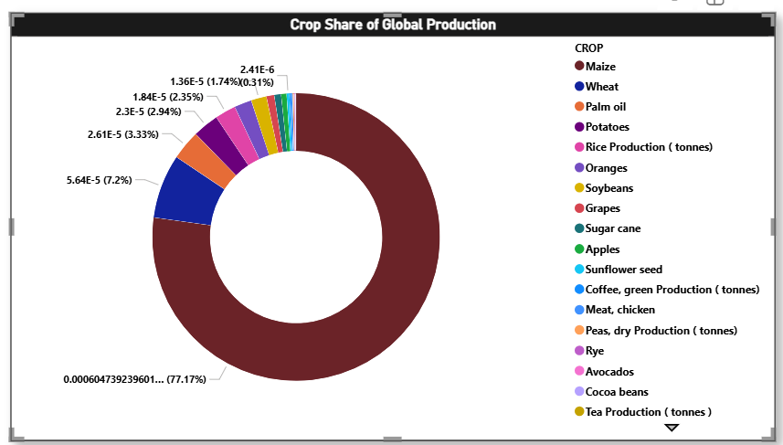

**8.What are the Top Food Producing Countries Globally?**

* **Visualization :** Bar chart showing top 10 countries by production volume.

